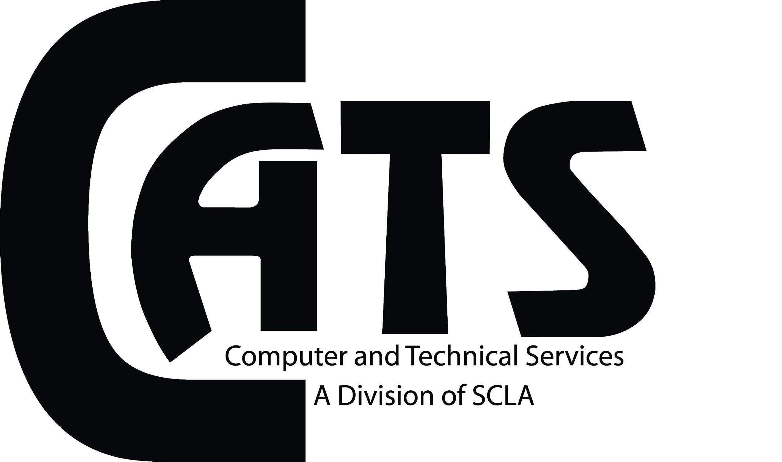
Approved Meeting minutes
Date: 12/12/18
Time: 9:30 AM
Location: SCLS Auditorium
Attendees: James H., Stephen Burg, Alison Mirabella, Nicole Parisi, Sylvia Maurer, Chris DeCristofaro, Mary O’Grady, Janet Kowal, Debbie Antolini, James Hansen, Nick Tanzi and Jesse Reinard
Non-Attendees: Anthony Bliss, Michael Bartolomeo, Paul Zukowski
Call To Order: 9:04 AM
Approval of the minutes:
- November 2018 and December 2017 minutes approved.
  - Mary O’Grady and Alison Mirabella
- December 2018 minutes will be approved in December 2019.
Treasurer’s Report:
- No report.
President’s Report:
- Introduction of incoming board:
  - Nicole Parisi: President
  - Alison Mirabella: Vice President
  - Sylvia Maurer: Secretary
  - Michael Bartholomew

Archives: Send documents for archives to sclacatsarchive@gmail.com.
Technology Information Forum (TIF):
- Next TIF meeting will be January 3rd.
Hospitality:
- None.
Membership:
- We currently have 115 members.
Newsletter:
- No report.
Publicity:
- No report.
Programs:
- Annual Meeting is today.

Next Meeting:
- January 13th at SCLS.
Adjournment:
- 9:11 AM, approved by Chris DeCristofaro and Stephen Burg.

