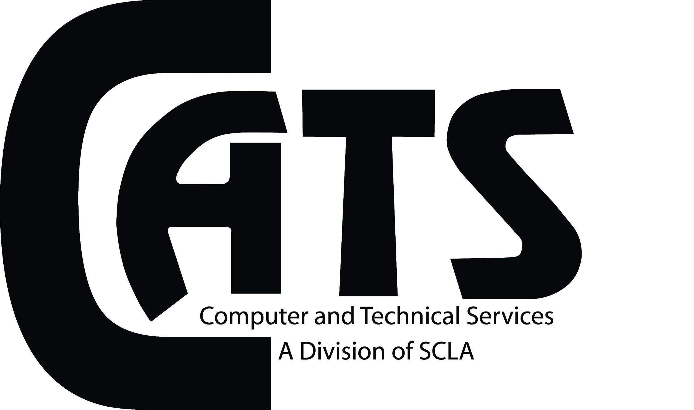
Approved Meeting Minutes
Date: February 10, 2022
Time: 10 a.m.
Location: Zoom Meeting

Attendees: Anthony Giansante, Chris Sarubbi, Michael Bartolomeo, Mary O’Grady, Julia Sukhu,
Debbie Antolini, Stephen Burg, Sara Fade
Non-Attendees: Chris DeCristofaro, Alison Mirabella, James Hansen, Nicole Parisi Eberle, Roseann
Mammina
Call To Order: 10:05 a.m.
Approval of January minutes:
- Corrections:
  - none
- Approved by:
  - Anthony Giansante
  - Stephen Burg
Treasurer’s Report:
- Julia reported: Balance as of 1/31/2022 is $1,598.15.
- Payment for speaker Maxine Bleisweis will be processed this week, amount is still part of balance. Timely processing of payments continues to be a problem with NYLA.

President’s Report:
Anthony reported.
- Anthony & Michael attended the SCLA division meeting.
- Many discussions about NYLA. $78k funds transferred from SCL to NYLA,
accounting needed for these funds; issues with disbursements from NYLA;
NYLA is several months behind in payments; NYLA is behind in issuing CEU’s.
- Advocacy day this year will be virtual, 2 sessions
- Long Island Library Conference cancelled for 2022
- Large drop in number of SCLA memberships and CATS memberships

Archives: Send documents for archives to sclacatsarchive@gmail.com.

Technology Information Forum (TIF):
- None. Report will be given at next meeting.

Hospitality:
- No update.
Membership:
- CATS membership was 89 last fiscal year and 47 this fiscal year. This is a large drop that
needs to be addressed.

Newsletter:
- No update

Publicity:
- No update

Programs:
- Tech Petting Zoo, summer date TBD, to be hoted by Roseann & Debbie
- New Programs: CATS board memebers, 2 person partnerships with original program ideas.
Send ideas, dates & locations (zoom, in-person, hybrid) to Anthony.

Web Site:
- Stephen reported. November & December meeting minutes were posted to webpage.
2022 CATS board members were also posted to webpage.

Old Business:
- Michael still waiting on reimbursement for December meeting refreshments.

New Business:
- 2022 Meeting Dates have been changed to first Wednesday of each month. Date change approved by vote of show of hands: all 8 board members in attendance at meeting voted “yes”. Anthony will email out a new list of meeting dates.
- Membership: discussed how to increase membership numbers:
- Original programming & run more programs
- CATS logo pens & tote bags: will be handed out for promotion at our individual libraries
- Chris will send emails with link to join SCLA & CATS
- Board members should check their institutional accounts for membership renewal and CATS membership status

- Anthony will request Alison make a membership renewal flyer

Next Meeting: March 2, Wednesday, 10 a.m. to be held virtually

Adjournment: 10:42 a.m.
  - Approved by Anthony Giansante
  - Seconded by Stephen Burg

Respectfully submitted,
Mary O’Grady, Recording Secretary

